**DTP EXAM ANSWERS**

**Q1) What is a computer? What are the Advantages and Dis-advantages of a computer?**

### Ans :

**Definition of a Computer:**A computer is a programmable machine. It responds to the specific set of instructions in a well-defined manner and it can execute a pre-recorded list of instructions.

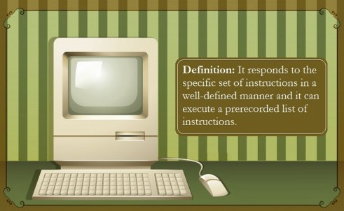

**Modern Computers:**Modern computers have two parts – an electronic part and a digital part. The hardware consists of wires, transistors, and circuits. The instructions and data are called software.

**Hardware Components Required:**

1. **Memory:** It enables a computer to share information and data.
2. **Mass Storage Device:** It allows a computer to retain large amounts of data. It included solid state drives (SSD) or disk drives and tape drives.
3. **Input Devices:** Devices such as keyboard and mouse enable us to pass data and instructions to the computer.
4. **Output Device:** Devices such as monitor and printer enable us to derive information from the computer.
5. **Central Processing Unit (CPU):** It is known as the heart of the computer. This is because it is the [**part of the computer**](https://informationq.com/about-the-basic-parts-of-a-computer-with-devices/) which is responsible for executing instructions.
6. **Bus:** Transmits data from one part of the computer to another.

**Advantages of a Computer:**

The computer from the beginning of its invention has changed a lot of things. It has changed the way of life of the society. It allows us to do various tasks quickly and easily hence saves a lot of labour, time and money.

Almost all major organizations use the computer for keeping records of their customers. Banks use computers for maintaining various accounts and managing money transactions. Nowadays online banking has also come into play. Computers have enabled us to check our account balance using the internet. Financial transactions have also been made online.

**Computers** can be used for regular tasks such as paying bills. Computers are also used for various entertainment purposes such as listening to songs and watching movies. Various social media such as Facebook, Instagram are used for sharing and communication.

Computers are used by students as an educational tool. Students can get a lot of information on the internet through a computer.

**Listed below are a Few Advantages of Computer:**

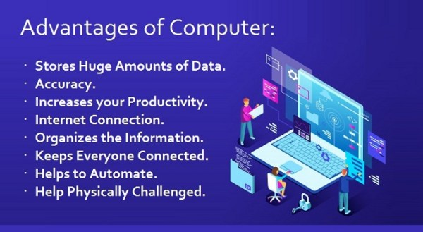

1. **Multitasking:** Multitasking makes a job easier and saves time. We can do many things together in a computer. We can perform multiple tasks, operations and calculate numerical problems within a few seconds.
2. **Speed:** A computer is more than a calculating device. It is very fast and allows us to do our tasks very quickly.
3. **Stores Huge Amounts of Data:** Computers can store a large amount of data. It can store files, documents, images, and videos.
4. **Accuracy:** Computers can solve numerical problems with accuracy.
5. **Data Security:** Computers can protect data. They secure us from cyber attackers. In cybercrime and cyber access is reduced.
6. **Increases your Productivity:**With the help of a computer, we can do any work with less effort and time. By using a computer we save our energy and time. We can create, store, edit, share and print documents. Without a computer, this may take a lot of time.
7. **Internet Connection:** The Internet is the main advantage of a computer. We can derive a lot of information in the form of documents or videos using the internet.
8. **Organizes the Information:** When we store a lot of information in a computer, we can arrange or segregate the information alphabetically, which helps us to find any information in no time.
9. **Keeps Everyone Connected:** We can stay connected with millions of people using a computer. There are various social media sites such as Facebook and Instagram through which we can share information with many people at the same time. For official purposes, we can use E-mail, which helps us send mail to a person in a short time. For video calling, we have applications such as Skype which enables us to talk to a person place to place, no matter where the other person is. Through YouTube, we can share content for others to see.
10. **A Tool for Students:** Computers can be a great tool for students. Students can use Google to get information about anything. They can use YouTube to understand a particular concept. In addition to that students can create and share documents among themselves.
11. **Can Get You Money:** By uploading contents on YouTube, you can earn a lot of money if you get enough subscribers. Starting an online store you can earn a lot of money as compared to a local store. This is because in online stores you can have global recognition and people from all over the world can order products from your site.
12. **Helps to Automate:** A great feature of a computer is to automate a machine. For example, in car manufacturing factories, a robotic arm can be programmed in such a way that it can repeat the steps we want it to do.
13. **Help Physically Challenged:**People who cannot talk can communicate through computers. People can also speak using a computer like Stephen Hawking. By installing special software a blind person can read what is on the screen.
14. **Dating Sites:** Millions of people have found their love through the internet. Dating sites enable us to contact people having common interests.
15. **Entertainment:** Computers can entertain us in various ways. We can now listen to millions of songs via the internet. We can surf social media in our free time. It allows us to download movies or watch them online.

**Disadvantages of a Computer:**

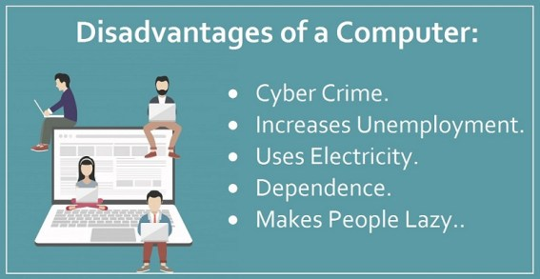

1. **Cyber Crime:** Since the computer is now used all over the world by millions of people to save data, hence there are some people who try to get the data by hacking an account. The illegal way of deriving information by sneaking through other’s account is known as cybercrime. People also hack other people’s social media account and do unwanted things to get them into trouble. There are some agencies which try to arrest these kinds of people.
2. **Increases Unemployment:** Computers have taken the place of man as computers are very fast and accurate and also save money and time. Due to this, unemployment has increased.
3. **Uses Electricity:** Some people are so dependent on a computer that they sit in front of a computer screen for the whole day. This uses a lot of electricity. Since electricity is an exhaustible resource, we must use it wisely.
4. **Dependence:** Some people are so addicted and dependent on a computer that they cannot live without it. It creates problems among loved ones and family members.
5. **Makes People Lazy:** Due to the convenience of the computer, people deny doing physical activity. This has made people lazy and unhealthy.

**Q2) Explain about CPU and its parts with the help of a neat diagram?**

# **Ans :**

## ****CPU Definition :**** CPU stands for “**Central Processing Unit**“, and it also known as the “**Processor**” and “**Brain**” of [**computer system**](https://digitalthinkerhelp.com/how-many-types-of-computer-and-their-functions/). CPU is placed on its compatible CPU socket, which is embedded on the [****motherboard****](https://digitalthinkerhelp.com/computer-motherboard-types-function-components/). CPU generates more heat while processing data, so it is connected with heat sink which helps to keep cool.

**Central Processing Unit (CPU) consists of the following features −**

* CPU is considered as the brain of the computer.
* CPU performs all types of data processing operations.
* It stores data, intermediate results, and instructions (program).
* It controls the operation of all parts of the computer.

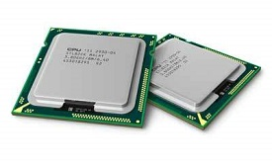

**CPU itself has following three components.**

* Memory or Storage Unit
* Control Unit
* ALU(Arithmetic Logic Unit)

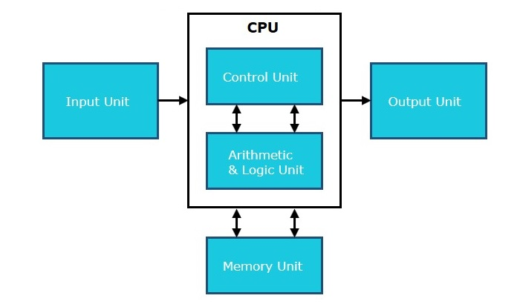

**1) Memory or Storage Unit**

This unit can store instructions, data, and intermediate results. This unit supplies information to other units of the computer when needed. It is also known as internal storage unit or the main memory or the primary storage or Random Access Memory (RAM).

Its size affects speed, power, and capability. Primary memory and secondary memory are two types of memories in the computer. Functions of the memory unit are −

* It stores all the data and the instructions required for processing.
* It stores intermediate results of processing.
* It stores the final results of processing before these results are released to an output device.
* All inputs and outputs are transmitted through the main memory.

**2) Control Unit**

This unit controls the operations of all parts of the computer but does not carry out any actual data processing operations.

Functions of this unit are −

* It is responsible for controlling the transfer of data and instructions among other units of a computer.
* It manages and coordinates all the units of the computer.
* It obtains the instructions from the memory, interprets them, and directs the operation of the computer.
* It communicates with Input/Output devices for transfer of data or results from storage.
* It does not process or store data.

**3) ALU (Arithmetic Logic Unit)**

This unit consists of two subsections namely,

* Arithmetic Section
* Logic Section

**(i)Arithmetic Section**

Function of arithmetic section is to perform arithmetic operations like addition, subtraction, multiplication, and division. All complex operations are done by making repetitive use of the above operations.

**(ii)Logic Section**

Function of logic section is to perform logic operations such as comparing, selecting, matching, and merging of data.

**Q3) What is a input and output devices? Explain with examples?**

## Ans :

## Input devices :

## An [input device](https://www.javatpoint.com/input-devices) can receive instructions from users or forward information to another device, but it is not able to accept data from another system. After receiving input, it translates these data into the electrical signals in binary code, which cannot be understandable by humans, and only a digital computer can understand it. There are many examples of input devices, which are discussed below:

* [**Keyboard**](https://www.javatpoint.com/input-devices#Keyboard)**and**[**Mouse**](https://www.javatpoint.com/input-devices#Mouse)**:** These are the input devices that are used by the users to give input to the computer. They send the received input (Data) from users to the system. As these are input devices, they cannot receive or display output (information) from the computer.
* [**Microphone**](https://www.javatpoint.com/input-devices#Microphone)**:** Another input device is a microphone that accepts sound generated by an input source and allows users to send audio into their computers. In the microphone, the accepted signal may be converted into a digital signal or can be amplified as an analog signal.
* [**Webcam**](https://www.javatpoint.com/input-devices#Webcam)**:** A webcam is a video camera that connects to a computer and faces the user, which is used to capture pictures, make a video by a computer system. It takes images as input from where it is pointed and used for calling and taking selfies. However, most modern webcams have a microphone, which offers users a better sound quality while making videos. Webcams are attached to the monitor of a desktop computer and also built into laptops.

**Output devices :**

[Output devices](https://www.javatpoint.com/output-devices) are the section of a computer device that receives data from another device and produces output with the information. Although it cannot send data to another device, it has the ability to forward data from a computer to another computer system. It functions to take data from input devices and translate the digitized signals into a form that can be understandable by users. There are various examples of output devices; some are discussed below:

* **Monitor:** A monitor is a piece of computer hardware that accepts data from a computer (output) and displays it on the system screen through the computer's video card. Monitors have the ability to display information at a much higher resolution. Additionally, these are much like televisions and also known as video screen, display, video display terminal, or video display unit.
* **Speakers:** The most common output devices, speakers accept sound data from a computer and play the sounds for users to hear. Although speakers can be used with any type of sound system, some speakers are manufactured only for computers. It is a device that cannot receive sound generated by users as well as refer that sound to another device. The main objective of the speakers is to produce sound or audio output for the listener.
* **Projector:** A projector is an output device that accepts data from a computer (output) and projects that data or information as a picture onto a wall or screen or any large surface. It does not have the ability to receive data from a user and also not capable of sending that data to another device. When you are showing video or images to a large group of people, a projector is more beneficial to use instead of a monitor because it displays data on a large surface that can be visible to a large number of people clearly.

**Difference between Input and Output devices :**

The below table contains major key points of the difference between both Input and Output devices.

|  |  |
| --- | --- |
| **Input device** | **Output device** |
| The input device receives data from users. | An output device displays data on the screen for users. |
| It works for translating user-friendly instructions into a machine friendly. | It works for translating the machine's instructions to user intelligible. |
| An input device can be commanded by the user. | Processor commands output device. |
| It accepts data from the user as an input and forwards it to the processor for further processing. | The data, which is processed by the processor, is sent to the output device for sending it back to the user; it means that the output device takes the processed data from the processor. |
| Its design is more complex. | As compared to input devices, its design is less complex. |
| Input device helps the computer to receive instructions from users. | The output device helps the computer to produce or display the information to the users. |
| There are various input devices available like Microphone, Joystick, Keyboard, Pointing device, Image Scanner, Graphics tablet, and more. | There are several output devices available such as Speakers, Printers, Plotters, Projector, Monitor and more. |

**Q4) please write atleast 10 shortcut keys of Desktop , MS Word and MS Excel ?**

**Ans :**

**Desktop Keys :**

|  |  |
| --- | --- |
| **Shortcut Keys** | **Explanation** |
| **Alt+Tab** | It allows you to **switch between open programs** on a computer. You are required to hold down the Alt key and keep pressing the Tab key to move from one program to another and release the Tab key when it is on the program that you want to open. |
| **Alt+E** | It is most often used to access **Edit Option** in the current program. There are some more uses of ALT+E, which are given below:   * **In Google Chrome,**it allows you to open the **File Menu** option. * In **Winamp**and **KMPlayer**, it brings up the **Toggle playlist editor.** * In **Blender**, it enables you to open the **Extrude menu.** |
| **Alt+F** | It enables you to access the **File menu options** in the current program. |
| **F1** | * **F1** is the first **Function key,** and it is used to display **help** **information** on every Windows program. * For example, in Microsoft Windows, it allows you to open the Microsoft Windows help and support screen by pressing **F1** and **Window key+F1**. * Furthermore, it is also used to access the Microsoft Office task pane by pressing **Ctrl+F1**. |
| **F2** | It provides users the option to **rename**an **icon** or a **file** which user selects. In MS word, if you press **Ctrl+F2**, the **print preview** option opens. |
| **F5** | It is mainly used to **refresh** the current window or contents of a file or a folder. Additionally, if you press **Ctrl + F5** or **Shift + F5** in a web browser, it reloads that web page irrespective of the cached content, and re-download the whole content of the web page. |
| **Ctrl+A** | It allows you to **select** the entire content of a page, including images and other objects. |
| **Ctrl+B** | It offers users with the option to **bold the selected text** of a page. It also has the various uses in different internet browsers, like in **Firefox** and **Netscape**, it is used to view the bookmarks, and in **Internet Explorer,** used to display the **favorites**. |
| **Ctrl+C** | It is used to **copy** the selected content, including other objects of a page. |
| **Ctrl+V** | It offers users with the option to **paste** the copied data. You need to copy data once, and then you can paste it any number of times. |
| **Ctrl+D** | It is mostly used in **internet browsers** to add the current site to a **bookmark** or **favorite**. |
| **Ctrl+F** | It provides users with the option to **find** or **search** text in the current document or window. |
| **Ctrl+I** | It allows the user to **italicize** and un-italicize the selected **text**. |
| **Ctrl+N** | It allows the users to create a **new** or blank **documen**t in Microsoft applications and some other software. It is also used in internet browsers to open a **new tab**. |
| **Ctrl+O** | It is widely used to open a file in the current software. |
| **Ctrl+K** | It has various uses, depending on the program. For example, in some applications, it is used to insert a **hyperlink,** and in **Internet browsers,** it focuses on the **search bar.** Such as**:**   * In **Chrome,** it opens Omnibox (search bar) * In **Firefox,**it opens search bar. * In **Internet Explorer,** it duplicates a current tab * In **Opera, it**checks e-mail. |
| **Ctrl+P** | It is used to open the **print** preview window for the current page or document. For example, if you press **Ctrl+P** when a browser or any other document window is open, you will see a print preview window of this page. |
| **Ctrl+S** | It is used to **save** the document or a file. You can also use **Shift+F12** to save the file in Microsoft Word. |
| **Ctrl+Y** | Its use is to **redo** any undo text and other objects, and it is also used to repeat the last performed action. |
| **Ctrl+Z** | It is used to **undo** the content and other objects. For example, if you have deleted the data by mistake, you can retrieve this data by pressing Ctrl+Z immediately. |
| **Shift+Insert** | It is used to **paste** the copied item. |
| **Shift+Delete** | It is primarily used to **delet**e the selected text, and it also provides the option to**delete**any folders or a file **permanently**. |
| **Home** | It is mainly used to bring the typing cursor to the starting of the line, which you are currently typing. If you press **Ctrl+home,** it returns the cursor to the beginning of a document, web page, or cell. |
| **End** | It is used to move the typing cursor at the **end** of the line, and it is also used to move the cursor to the end of the document by pressing **Ctrl+End**. |
| **Alt+Enter** | It is widely used to access the **properties** of the selected item, such as **file,** **folder**, or any other **objects**. |
| **Alt+F4** | It is used to **close** the **currently open window**. For example, if you press Alt+F4 when the browser window is open, it will close the browser window and other open tabs. Additionally, you can use this key to **shut down** the system, for that you need to press **Alt+F4** on **desktop screen**, and you will see a dialog box then click **OK button**, the system will **shut down**. |
| **Ctrl+Esc** | It will open the **start menu**. You can also use the **Window Key** to open the start menu. |
| **Ctrl+Shift+Esc** | It provides users with the benefit to quickly open the **Windows Task Manager** in all versions of Windows since Windows 95. |
| **Shift+Home** | By pressing Shift and Home keys together, you can **select all text** from the current position of the cursor to the beginning of a line. |

**Microsoft Word Shortcut Keys :**

**A simple list of Microsoft Word shortcut keys is given below with explanation.**

1. **Ctrl+A:** It is used to **select** all content of a page, including images and other objects.
2. **Ctrl+B:** It provides users with the option to **bold** the selected item of a page.
3. **Ctrl+C:** Its use is to **copy** the selected text, including other objects of a file or page.
4. **Ctrl+D:** It is used to access the **font** preferences window, which offers several options such as font size, font style, font color, etc.
5. **Ctrl+E:** It is used to **align** the selected item to the **center** of the screen.
6. **Ctrl+F:** It helps users to **find** or **search** data in the current document or window.
7. **Ctrl+G:** It is used to **Go To** or jump to any page. When you press Ctrl+G, a dialog box appears, which offers you various options such as find, replace, and **Go to**. For example, you have 15 pages in your file, and you want to visit page number 4, then enter number 4 in the given box and press the **Go To** It will take you to the desired page. As shown in the below figure:
8. **Ctrl+H:** It is used to **replace** the words or sentences in a file. For example, if by mistake you have written spple instead of apple at many places in your file, you can replace it with the apple in one go.
9. **Ctrl+I:** It offers an option to ***italicize*** and **un-italicize** the highlighted text.
10. **Ctrl+J:** It is used to **Justify** (distribute your text evenly between the margins) the selected text.
11. **Ctrl+K:** It allows you to insert the **hyperlink**. For example, [http://www.javatpoint.com](https://www.javatpoint.com/)
12. **Ctrl+L:** It is used to adjust **(align)** the selected content to the left of the screen.
13. **Ctrl+M:** It provides users with the option to **indent** the As shown in the below picture:
14. **Ctrl+N:** It is used to open a **new**or **blank** **document** in Microsoft applications and some other software.
15. **Ctrl+O:** It is used to **open** the dialog box where you can choose a file that you want to open.
16. **Ctrl+P:** It is used to open the **print** preview window of a document or a file. It can also be done by pressing **Ctrl+F2** and **Ctrl+Shift+F12**.
17. **Ctrl+Q:** Its use is to **align** the selected paragraph to the
18. **Ctrl+R:** It offers users the option to **align** the line or selected content to the **right** of the screen.
19. **Ctrl+S:** Its use is to **save** the document or a file.
20. **Ctrl+T:** It gives users the benefit of creating a **hanging indent** for a paragraph.
21. **Ctrl+U:** It is used to **underline** the selected text.
22. **Ctrl+V:** It is used to **paste** the copied data. It allows you to copy data once, and then you can paste it any number of times. You can also paste the data by using **Shift+Insert**.
23. **Ctrl+W:** Its use is to **close** the currently open **document** or a file quickly.
24. **Ctrl+X:** If you want to cut some text, you can use this key to **cut** the selected content. You can also paste it by using **Ctrl+V**.
25. **Ctrl+Y:** It allows the users to **redo** the last action performed in a file. For example, you have written a word mango; you can repeat this word multiple times by pressing **Ctrl+Y**.
26. **Ctrl+Z:** It is used to **get back** the deleted item. For example, if you have deleted the data by mistake, you can press Ctrl+Z to retrieve (**Undo**) the deleted data. It can also be done by pressing **Alt+Backspace**.
27. **Alt+F, A:** It allows users to use the **Save As** option, which means to save a file with a different name. For that, you need to press **Alt+F,** which displays a dialog box or a page, then press A for Save As option. It can also be done simply by pressing
28. **Ctrl+Shift+L:** This key is used to create a bullet point in the file quickly.
29. **Ctrl+Shift+>:** It **increases** the **font size** by +1pts up to 12pt thereafter increases by +2pts.
30. **Ctrl+Shift+<:** It is used to **decrease**the **font** If the font size is 12pt or lower; it decreases the font by -1pts, and if the font size is above 12, it decreases the font by +2pts.
31. **Ctrl+]:** Its use is to **increases** the **font** size by **+1pts.**
32. **Ctrl+[:** It is used to **decreases** the **font** size by **-1pts.**
33. **Ctrl+/+C:**It offers users the option to **insert** a **cent sign (¢).**
34. **Ctrl + (Left arrow ←):**I t allows users the benefit to **move**one word to the **left** in the line or a paragraph.
35. **Ctrl + (Right arrow →):** It is used to **move** one word to the
36. **Ctrl+Shift+*:**It is used to show or hide non-printing characters.
37. **Ctrl + (Up arrow ↑):** This key is used to **move**the typing **cursor**to the beginning of the line or paragraph.
38. **Ctrl + (Down arrow ↓):** It enables you to **move**the typing **cursor** to the end of the paragraph.
39. **Ctrl+Delete:** It allows users to **delete**a word to the **right** of the cursor.
40. **Ctrl+Backspace:** It allows users to **delete** a word to the **left**of the cursor.
41. **Ctrl+End:** Its use is to move the **cursor** to the **last** of the document.
42. **Ctrl+1:** It is used to give a **single line space**. For example, to make the 1.0 space between the lines of a paragraph.
43. **Ctrl+2:** It is used to give the **double line space**. For example, to make the 2.0 space between the lines of a paragraph.
44. **Ctrl+5:** It is used to make the **5 space** between the lines of a paragraph.
45. **Ctrl+Spacebar:** It enables you to **reset** the selected text to the **default font.**
46. **Ctrl+Home:** It allows you to move the **cursor** to the **beginning** of the document.
47. **Ctrl+Alt+1:** It changes text format to **heading 1.**
48. **Ctrl+Alt+2:** It changes text format to **heading 2.**
49. **Ctrl+Alt+3:** It changes text format to **heading 3.**
50. **Alt+Ctrl+F2:** It is used to open the **new file** or a document.
51. **Ctrl+F1:**I ts use is to open the **task pane** in some Microsoft office versions, in word 2016, it is used to hide and show the **ribbon**.
52. **Ctrl+Shift+F6:** It allows the users to **switch** between open documents in Microsoft Word.
53. **F1:** The function key **F1** is used to open the **help and support**
54. **F4:** It enables you to repeat the last action performed. For example, when you want to retype the last typed word multiple times, you can use this key.
55. **F5:** It is used to access the **find and replace**dialog box, including **Go to**
56. **F7:** It provides users the advantage to check **spelling** and **grammar** of selected text or document.
57. **Shift+F3:** It is used to use the change case option where you can change the text from uppercase to lowercase or a capital letter at the beginning of every word.
58. **Shift+F7:** It offers users the option to check the **thesaurus** of the selected word. You need to select the word and press this key.
59. **Shift+Alt+D:** It is used to insert the **current date**.
60. **Shift+Alt+T:** Its use is to insert the **current time**.

**Microsoft Excel shortcut keys :**

If you work on [Microsoft Excel](https://www.javatpoint.com/excel-tutorial), you can use the number of keyboard shortcut keys to speed up your work and make it more convenient. We have tried to provide a simple list of shortcut keys.

**The following table contains the commonly used shortcut keys for Microsoft Excel with description.**

|  |  |
| --- | --- |
| **Shortcut Keys** | **Description** |
| **Ctrl+Shift + ;** | It is used to insert the **current time**. |
| **Ctrl+;** | It is used to enter the **current date**. |
| **Shift + F3** | Its use is to open the **Excel formula's** window.' |
| **Shift + F5** | It provides users the option to display the **find and replace** dialog box. |
| **Ctrl + A** | Its use is to **select** or highlight **all contents** of a worksheet. |
| **Ctrl + B** | It allows you to **bold** all selected items of an Excel sheet. It can also be done by pressing **Ctrl+2**. |
| **Ctrl + C** | It is used to **copy** the selected content of a worksheet. |
| **Ctrl + D** | It enables you to **fill down** the **cells**with the content of the selected cell. As shown in the below picture: Computer Shortcut Keys |
| **Ctrl + F** | It offers the option to open **find**and **replace**dialog box quickly. You can also use **Shift + F5** for it. |
| **Ctrl + G** | It is used to open the **go-to** option dialog box where you can go to the specific cell. It can also be done by using **F5**. |
| **Ctrl + H** | It allows you to **find and replace** the word or sentences in a file. For example, if by mistake you have written a somputer instead of the computer at many places in your sheet, you can replace it with the computer in one go. |
| **Ctrl + I** | It is used to put ***italics*** on all cells in the selected section. It can also be done by pressing **Ctrl+3**. |
| **Ctrl + K** | It provides the option to insert a **hyperlink**in a file. |
| **Ctrl + L** | It enables you to access the **create table** dialog box. |
| **Ctrl + N** | Its use is to open the **new document** or a workbook. |
| **Ctrl + O** | It offers users the option to **open** the dialog box where you can choose a file that you want to open. You can also use **Ctrl+F12** to open a file. |
| **Ctrl + P** | It allows you to **print** a current sheet or a document quickly. |
| **Ctrl + Q** | It is used to display the **quick analysis options** for the selected cells with data. As shown in the below image: Computer Shortcut Keys |
| **Ctrl + R** | It allows you to **fill** the **cells** to the **right** with the content of the selected cell. As shown in the below screenshot: Computer Shortcut Keys |
| **Ctrl + S** | Its use is to **save** the document. It can also be done by using **Alt+Shift+F2**. |
| **Ctrl + T** | It offers users the option to display the **create table** dialog box. |
| **Ctrl + U** | It is used to **underline** all selected cells. You can also use the shortcut key **Ctrl+4**to underline the cells in the Excel sheet. |
| **Ctrl + V** | It provides users the option to **paste** the copied data onto the Excel sheet. You are required to copy the data once, and then you can paste it any number of times. |
| **Ctrl + W** | It is used to **close** the currently **open document** or a file quickly. It can also be done by pressing **Ctrl+F4**shortcut keys. |
| **Ctrl + X** | It allows users the option to **cut** the entire data of the selected cells in an Excel sheet. |
| **Ctrl + Y** | It provides users the option to **redo** any undo contents. |
| **Ctrl + Z** | It is used to **undo** (get back) the deleted item. For example, if you have deleted the data by mistake, you can press Ctrl+Z to retrieve the deleted data. It can also be done by pressing **Alt+Backspace**. |
| **Ctrl + Page up & Page Down** | It allows you to move from one worksheet to another worksheet in the same Excel file. |
| **Ctrl + F6** | It enables the users to **move**from one **document** to another document in Microsoft Excel. It can also be done by pressing **Ctrl+Tab**. |
| **Ctrl + F9** | It enables users the option to **minimize** the current window. |
| **Ctrl + F10** | It uses to **maximize** the currently selected window. |
| **F1** | It is used to open the **help** screen window. |
| **F2** | It allows you to **edit** the selected cell in the Excel sheet. |
| **F4** | It provides users the option to **repeat**the**last action**. For example, if you change the red color of the text in a cell, by pressing F4, you can apply the same text color in another cell. |
| **F7** | It is used to **check** the **spelling** of the selected text. |
| **F10** | The function key F10 is used to **activate** the **menu bar**. For example, if you want to open the file menu, you need to press **F10,** then **F**. |
| **F11** | Its use is to **create** a **chart** in Excel. |
| **F12** | It enables you to use the **Save As** option, which allows you to save a file with a different name. It can also be done by using **Alt+F2**. |
| **Alt + =** | It allows you to use the **formula** to add the data of all the above cells. |
| **Ctrl+Shift+"** | It allows you to copy the content of a cell and to paste it into a cell, which is just below it. It can also be done by using **Ctrl+"** key. For example, if you have written "Excel" in cell B1 and its below cell is B2, by pressing **Ctrl+Shift+" or Ctrl+'** the word "Excel" will be copied in cell B2. |
| **Ctrl + Shift + !** | It is used to apply **comma** format in numbers. For example, as shown in the below image: Computer Shortcut Keys |
| **Ctrl + Shift + $** | Its use is to apply **currency** format to numbers. As shown in the below screenshot: Computer Shortcut Keys |
| **Ctrl + Shift +%** | It provides users the option to apply **percentage sign** to numbers. For example, see the below picture: Computer Shortcut Keys |
| **Ctrl + Space** | It enables you to **select** the entire active **columns**. |
| **Shift + Space** | It enables you to **select** the entire active **rows**. |
| **Ctrl + (Right arrow →)** | It allows the users to move the cursor to the next cell, which contains the text. |
| **Ctrl + 1** | It is used to open the **format cells** dialog box where you can change the text format like text color, font size, font style, text alignment, etc. It can also be done by pressing **Ctrl+Shift+F** or **Ctrl+Shift+P**. |
| **Ctrl + 5** | Its use is to put the **strikethrough** to all selected cells. As shown in the below picture: Computer Shortcut Keys |
| **Ctrl + 9** | Its use is to **hide** the selected **rows**in the worksheet. |
| **Ctrl + Shift + (** | Its use is to show **(unhide)**the hidden rows. |
| **Ctrl + 0** | It is used to **hide** the selected **columns**. |
| **Ctrl + - (Minus)** | It will open a **delete** dialog box where you can delete a selected row or column. |
| **Ctrl + Shift + =** | It will open the **insert** dialog box where you can insert the new row or a column. |
| **Ctrl + Shift + ^** | It is used to make an **exponential** form of any number. For example, you have written a number 12345 in the worksheet, and if you press Ctrl+shift+^, the number will be changed 1.23E+05 in exponential form. |
| **Ctrl + Shift + &** | It offers users the option to make a **border** around the selected cells. |
| **Ctrl + Shift+ _** | It offers users the option to remove a border around the selected cells in a worksheet. |
| **Ctrl+Shift+Spacebar** | It is used to **select**the **entire worksheet**. |
| **Ctrl + Home** | It allows the users to **move** the cursor to the beginning **(cell A1)** of the worksheet. |
| **Ctrl + End** | It is used to **move**the cursor to the **last cell** with text on the worksheet. |
| **Shift + Page Up** | It allows you to **select all** the cells located **above** the selected **cell.** |
| **Shift + Home** | It enables you to **select all** cells to the **left** of the current active **cell**. |
| **Shift + (Up Arrow ↑)** | It enables you to extend the selected area up by one cell. |
| **Shift + (Down Arrow ↑)** | It enables you to extend the selected area down by one cell. |
| **Alt + Enter** | It allows the users to write in multiple lines in one cell. For example, if you are typing in a cell, it enables you to **move on** the **next line** in one cell by pressing **Alt+Enter**. |
| **Alt + '** | It is used to access the **style** dialog box. |
| **Ctrl + F3** | It is used to open the **name manager** in Microsoft excel. |
| **Ctrl + F5** | Its use is to **restore** the Window size. |
| **Ctrl + F11** | It is used to insert a **macro** **sheet**in Microsoft excel. |
| **Alt + F8** | It is used to display the **macro** dialog box. |

**Q1) What is a Folder? What are the Steps to create a Folder?**

## File Explorer : In Windows, the primary way of interacting with files and folders is through the File Explorer application. (In older versions of Windows, this may be called Windows Explorer. In Macs, the equivalent would be Finder.) There are a couple of ways to open File Explorer. The shortcut Win+E will open File Explorer. It can also be opened by clicking the Start button and typing “File Explorer” or by right-clicking any folder and selecting Open. By default, File Explorer is pinned to the task bar (see below), and it can be opened from there.

|  |  |
| --- | --- |
| **[Start menu displayed with a search for file explorer in progress.](https://s3-us-west-2.amazonaws.com/courses-images/wp-content/uploads/sites/1844/2017/05/09204004/Screen-Shot-2017-05-09-at-1.38.14-PM.png)**  Open the Start menu and type “File Explorer.” | File explorer highlighted in the windows 10 task bar.  Find File Explorer pinned to the taskbar. |
| A right click of a file leading to a set of new options including, "Open", "Pin to Quick access", and "Scan with Windows Defender".  Right-click a folder and select Open. |

Some folders already exist in File Explorer, such as Documents, Desktop, and Downloads. (Documents may be called “My Documents” in older versions of Windows). You can create more folders or folders within folders to allow for better organization.

To create a folder, right-click, then select New>Folder.

**[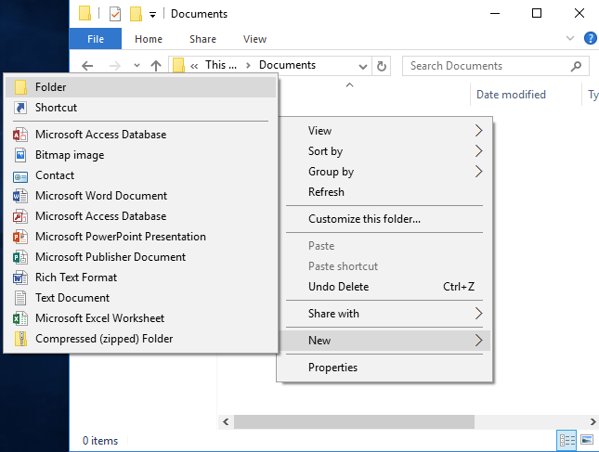](https://s3-us-west-2.amazonaws.com/courses-images/wp-content/uploads/sites/1844/2017/05/22231206/fileexplorer-newfolderoption.png)**

Right-click in File Explorer, then select New>Folder.

In Windows 7, there is a New folder button near the top of the window. In Windows 10, you can also click the Home tab, then the New Folder button.

|  |
| --- |
| **[A file finder window is open specifically on the documents page. There is a green arrow pointing towards the option to create a "New Folder" in Windows 7.](https://s3-us-west-2.amazonaws.com/courses-images/wp-content/uploads/sites/1844/2017/05/22213727/fileexplorer-win7-newfolderbutton.png)[A file finder window is open specifically on the home page. There is a green 2 indicating to where the option to create a "New Folder" in Windows 10 is.](https://s3-us-west-2.amazonaws.com/courses-images/wp-content/uploads/sites/1844/2017/05/22213743/fileexplorer-win10-newfolderbutton.png)**  Windows 7 New folder button |

## Renaming Files

To rename a file or folder, right-click the file or folder, then select Rename.

**[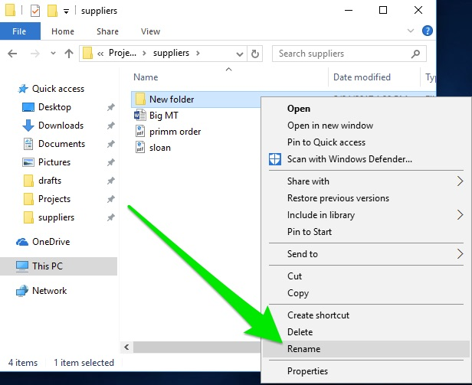](https://s3-us-west-2.amazonaws.com/courses-images/wp-content/uploads/sites/1844/2017/05/24203159/fileexplorer-rename.jpg)**

You can also click the name of the file or folder once, wait one second, then click the name of the file or folder again.

Note that in Windows, a file cannot contain any of the following characters: \ / : * ? " < > |. This is because those characters have special meaning in Windows. (For example \ is included in file paths.) If Windows encounters a file or folder with those symbols, it could potentially misread the file or folder name and cause problems. As a precaution, Windows will not let you save files or folders with those characters, so don’t worry about saving a file with those characters in the name by mistake.